# **Exercise Set#1 - Understanding Shell, Environment Variables, Login/Logout Process, Aliases**

**Shell**

Explore and Understand the below topics:

**Videos :** Linux1-what_is_linux, Linux1-customizing_Linux_terminal

**1. Understanding the Shell**

**a. What is “Shell” in Linux?**

**Ans :**

A shell is a special user program that provides an interface for the user to use operating system services. Shell accepts human-readable commands from users and converts them into something which the kernel can understand.

**b. What are the different types of “Shells” available?**

**Ans :**

Following are some of Shells available. Each of these shells has properties that make them highly efficient for a specific type of use over other shells.

* BASH (Bourne Again Shell)
* CSH (C SHell)
* KSH (Korn Shell)
* TSH(T Shell)
* ZSH(Z Shell)

Each shell does the same job but understands different commands and provides different built-in functions.

**c. Find out the supported shell file in the Linux file structure.**

**Ans :**

Supported shell files can be found in “shells” directory which is present in etc directory

etc directory contains configuration files required by all programs.

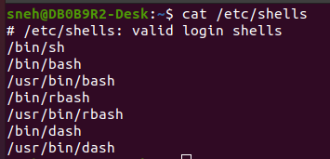

**d. Which Shell are you using?**

**Ans :**

ps, echo $0, echo $SHELL, etc. Commands can be used to know the shell which is currently used.

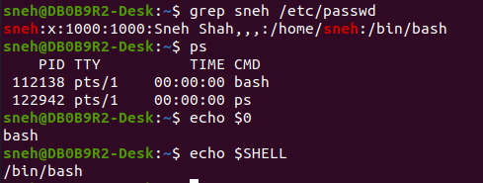

**e. Switch to some another shell.**

**Ans :**

chsh is the utility to change a user’s login shell. chsh provides the -s option to change the user’s shell. This method also modifies the file /etc/passwd.

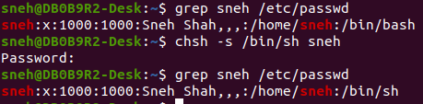

**2. Understanding the Environment variables**

**a. What are “environment variables” in Linux?**

**Ans :**

They are container which may be used by one or more programs running.

They provide essential information to Software.

They are used by the operating system and various applications to determine settings, paths, and configurations.

**b. What are the common “environment variables”?**

**Ans :**

Some of the common Environment Variables are as follows :

USER - Gives name of user

PATH - Gives Path

HOME - Gives Path to Home Directory

PWD - Gives path to present working directory

SHELL - Gives Path to current shell

**c. Display the environment variable of your system using <env> or <printenv> command**

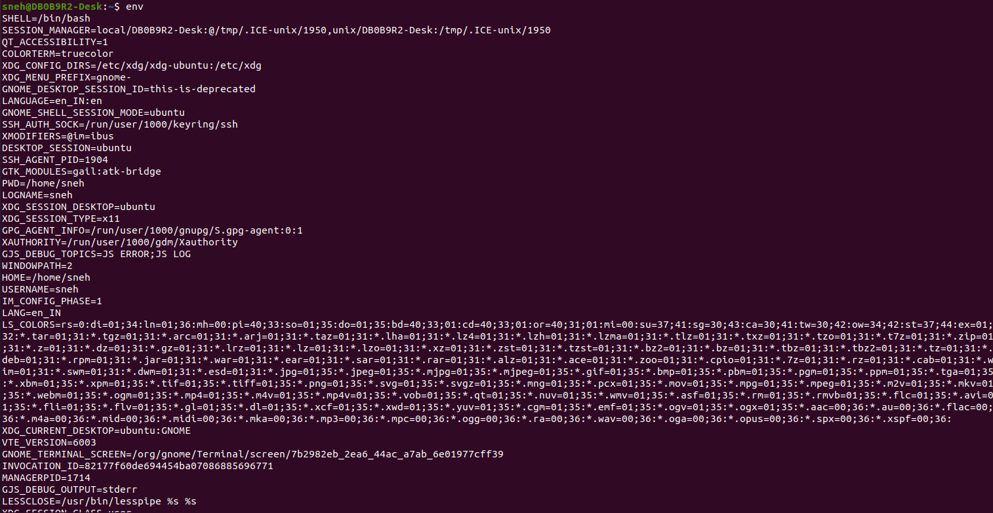

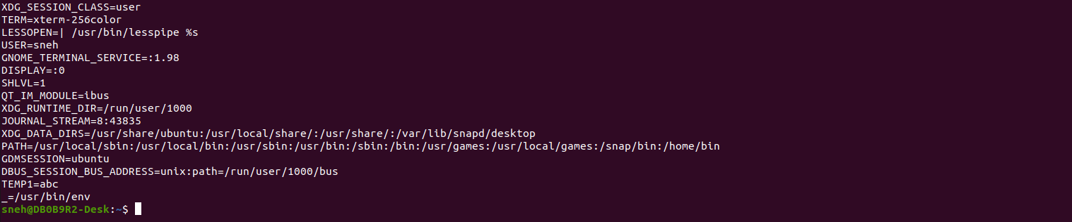

**d. Explore the different variables printed by the above command**

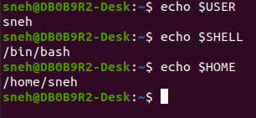

**e. Learn more about the “PATH” variable. What is the role of PATH variable?**

**Ans :**

The PATH environment variable plays a crucial role in the Linux operating systems. Its primary function is to specify a set of directories where executable programs are located. When you type a command in the terminal, the system looks for the corresponding executable file in the directories listed in the PATH variable.

**f. Display the current path settings using the <echo> command and the “PATH” variable**

**Ans :**



**g. Make a “bin” directory in the /home folder. Add the path of this folder to the “PATH” variable using the <export> command OR the “PATH” variable**

**Ans :**



**h. What is the validity of the settings of environment variables done in this fashion?**

**Ans :**

Using above export command changes made will be on a temporary basis and are valid only for the current terminal session.

For permanent changes for the user we need to edit .bashrc file.

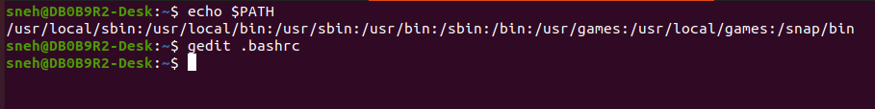

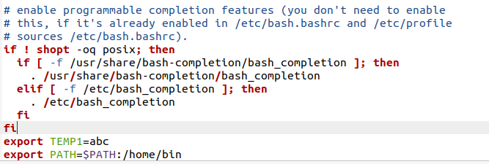

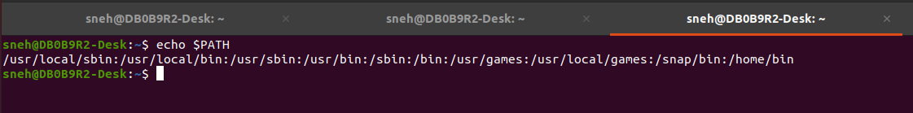

**3. Login, logout processes**

**a. Find out which files are being executed once the user log’s in the system and when the user logs out of the system; e.g. If it is an bash shell then look for “.bash_profile” user login profile and “.bash_logout” logout profile.**

**Ans :**

/etc/profile, ~/.bash_profile, ~/.bashrc are some commonly executed when user login to the system.

And ~/.bash_logout file is commonly executed when user logout from system.

**b. Analyze the contents of the login profile, logout profile.**

**Ans :**

/etc/profile: System-wide profile script executed for all users.

~/.bash_profile: User-specific initialization file. It is executed for login shells.

~/.bashrc: User-specific Bash initialization script executed for all interactive shells.

~/.bash_logout file is executed when a user logs out.

**c. Make a new folder in “/home”.**

**d. Edit the login profile to add the new folder path in the login profile.**

**e. Logout and login again and the check the environment path. The new folder path which was added should be reflected in the PATH variable.**

**Ans :**

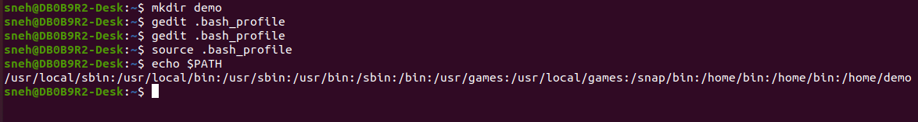

f. What is the difference between “/etc/profile” and “~/.bash_profile”?

Ans :

/etc/profile : Applies settings and environment variables globally to all users on the system during login.

Whereas,

.bash_profile : Applies settings and environment variables specifically to an individual user during their login.

**4. Aliases**

a. What are “aliases”?

Ans :

Alias is like a shortcut command which will have same functionality as if we are writing the whole command.

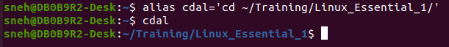

But it is for same terminal session.

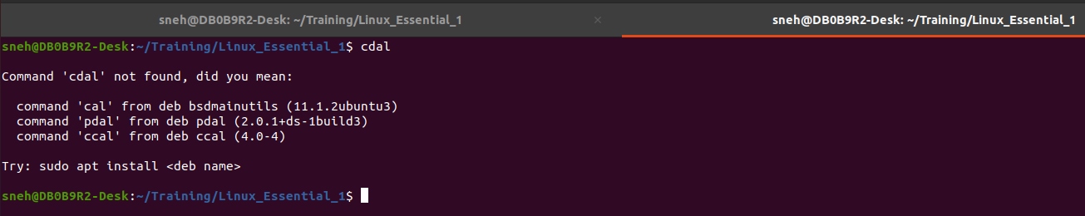

b. Analyze the shell rc file; e.g. In case of bash shell the shell rc file is “.bashrc”.

Ans :

.bashrc is user-specific configuration file.

c. Edit the shell rc file to add one alias to any command.

Ans :

To save Permanent Alias for a use we add it in .bashrc file

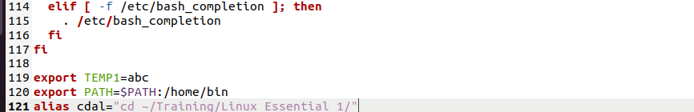

d. Execute the added aliases and check if the operation is successfully completed.

